{Practice Name}  Nursing Policy & Procedure Manual  Policy/Procedure Number: 5.2 | Effective Date: 10/01/04  Revised Date: ________  Version 1.0

Patient Education: Self-administration of Subcutaneous and Intramuscular Injections

Definition/Purpose: The patient should be supported to be as independent and involved in his/her care and treatment as is medically necessary or desired. It is therefore important to teach patients and/or caregivers to safely administer subcutaneous and intramuscular injections for use outside the office setting.

Personnel Responsible: Licensed Nurses, Medical Assistants

Equipment/Supplies Required:
- Sharps container
- Alcohol swabs
- Medication to be injected
- An appropriately sized syringe
- 2x2 gauze
- Band-Aid
- 2 appropriately sized needles
IM: 1-1½ inches/22 to 25 gauge
SQ: 3/8-5/8 inches/25 to 27 gauge (size of gauge depends on volume being administered) or prefilled syringe or “pen” (eg, insulin or interferon)

Policy:
All patients who will be self-administering subcutaneous and/or intramuscular injections at home will be assessed for their ability to learn the procedures and taught the appropriate method for administration.

Procedural Steps:
- The physician will complete and sign the order/prescription for medication to be administered by patient and/or caregiver at home including name of medication, dose, route of administration, frequency, and length of treatment.
- The nurse will assess the patients and/or caregiver’s ability and readiness to learn. This assessment should include a review of:
- Primary language and level of understanding
- Relevant cultural norms
- Ability to read, including adequate eyesight
- Anxiety level
- Physical/mental status, manual dexterity
- Level of decision-making ability and desired degree of participation in care
- Depending on ability and the readiness to learn assessment, the patient and/or caregiver will be offered a variety of resources to enhance learning, including but not limited to:
- Verbal instruction
- Demonstration
- Video tapes
- Pictures
- Tactile learning instructions
- Refresher demonstration(s)
- The patient and/or caregiver will be taught to safely self-administer needed medication, verbalizing an understanding of the procedure and demonstrating correct technique for independent self-administration.

Patient/Caregiver Instructions:
- Patient/caregiver must have access to medications and supplies from a pharmacy or home health agency, or the office may dispense them based on health care insurance coverage policies.
- Instruct patient/caregiver when to call doctor/nurse:
- Redness, swelling, discharge, discomfort, or rash at injection site
- Questions on injection procedure or medication administration
- Provide written instructions with step-by-step procedures and injection site diagram to patient and/or caregiver.

Documentation:
A. Release of Liability Form

B. Medical Records
- Document teaching with return demonstration, including participants, date of teaching, and supplies and/or medications provided by office, patient’s and/or caregiver’s response to teaching, and name of instructor.
- Recipient (patient and/or caregivers) should provide a signature that indicates education was received for self-administration.

C. Billing
Mark the appropriate charges on encounter form, including supplies and/or medication provided. Bill for a Level 1 E&M code (99211-nurse visit) if appropriate.

Drawing Up a Liquid Medication for Injection

- Equipment—For your injection, you will need the following: drug to be injected, alcohol swabs, a syringe, and needles. Diagram below shows the parts of a syringe and needle.

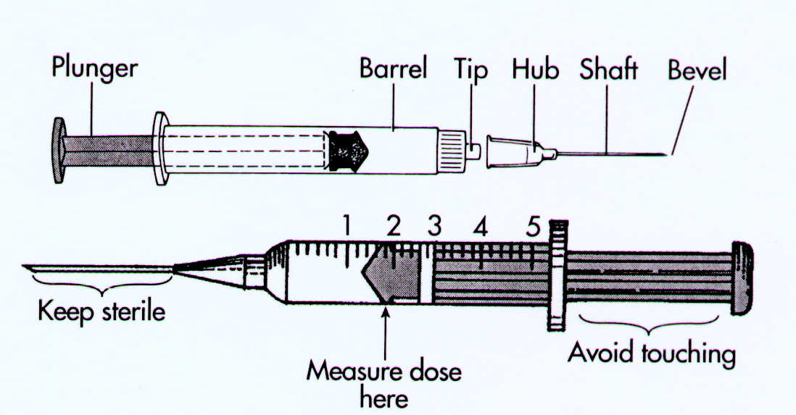

- Procedure—Before drawing up the medication, prepare as follows:
- Wash your hands and your work area thoroughly with soap and water.
- Remove the top from the drug vial. Wipe the rubber top with an alcohol swab. (Swabbing the vial top with alcohol is required only with use of “multi-dose” vials that contain several doses of a medication or if rubber top has been contaminated.)
- Check to make sure needle is tightly attached to the syringe by turning clockwise.
- To remove needle cap (guard), pull straight off.
- Touch only the flat knob at the end of the syringe; do not touch the needle or plunger.
Measuring Drugs with a Syringe
- Inject a small amount of air in the vial (equal to the amount of medication to be administered).
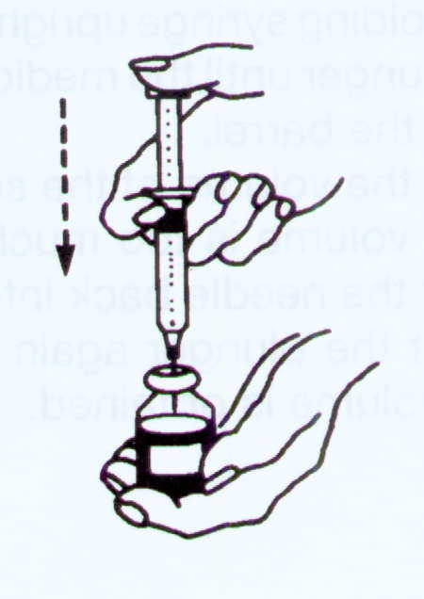
- Turn the vial upside down and withdraw the medication. The tip of the needle should be below the fluid line to avoid getting air into the syringe.
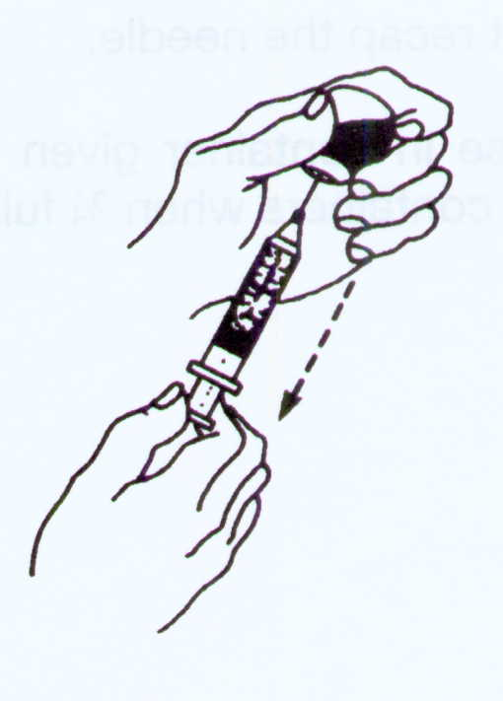
- Remove air or bubbles from the syringe as follows:
- Hold the syringe upright
- Pull the plunger back slightly
- Gently tap the barrel of the syringe so that air bubbles float to the top.
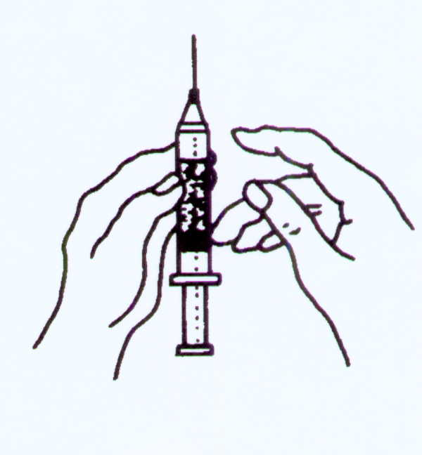
- Still holding syringe upright, slowly push the plunger until the medication is at the tip of the barrel.
- Read the volume of the solution.
- If the volume is too much or too little, wipe rubber vial top with alcohol and insert the needle back into the vial. Adjust the plunger again until the correct volume is obtained.
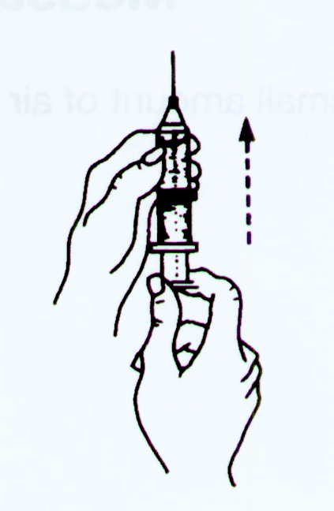
- Do not recap the needle.
- Dispose in sharps container given to you and return container when ¾ full.

Administration of a Subcutaneous Injection

- Your doctor has prescribed the medication _______________, which will be injected into your skin. This is called a subcutaneous injection.
- Equipment—You will need the medication, alcohol swabs, a syringe (Figure 1), and needles. Your nurse will show you which syringe you will be using. Syringes can be purchased at your local pharmacy with a prescription. Some medications are packaged in pre-filled syringes (Figure 2).
Figure 1

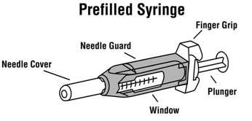
Figure 2.
- Procedure:
- Wash your hands and your work surface with soap and water.
- Locate your site of injection (upper outer arm, abdomen, outer thigh). See Figure 3 on the next page for possible injection sites on the body.

Figure 3. Sites for Subcutaneous Injection

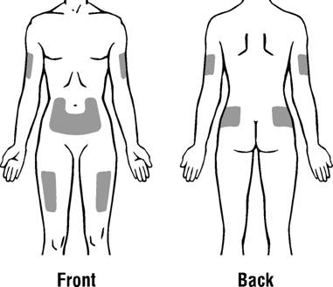

- Cleanse the area of skin with an alcohol swab and allow to dry.
- Gently pinch up the skin surrounding the site of injection and hold firmly.
- Insert the needle at a 45-degree angle (see angle shown in Figure 4 below)
- Once the needle is in the skin, release the grasp on the skin.
- Pull back gently on the plunger of the syringe; if no blood appears, inject the medication slowly.

Figure 4. 45-degree angle for injection technique
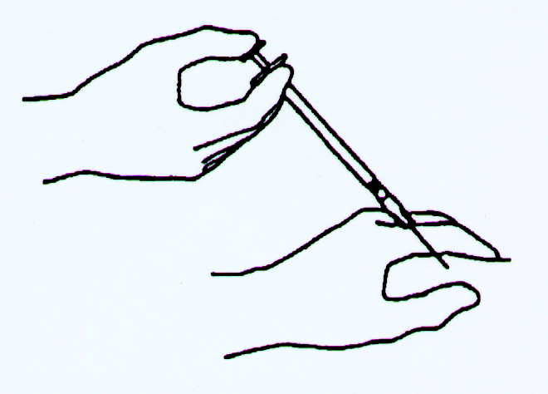

- If blood appears, withdraw the needle and apply gentle pressure to the site. Then change the needle and begin at another site.
- Withdraw the needle when the correct amount of medication is given.
- Immediately apply gentle pressure with an alcohol swab, gauze, or tissue until bleeding has stopped.
- Place a Band-Aid over injection site if needed.
- Be sure to rotate your injection site using pictures provided.
- Discard uncapped needle and syringe into appropriate container.

Administration of an Intramuscular Injection

- Your doctor has prescribed the medication __________________, which will be injected into your muscle. This is called an intramuscular injection.
- Equipment—You will need the medication, alcohol swabs, a syringe (Figure 1), and needles. Your nurse will show you which syringe you will be using. Syringes can be purchased at your local pharmacy with a prescription. Some medications are packaged in pre-filled syringes (Figure 2).
Figure 1.

Figure 2.

- Procedure:
- Wash your hands and your work surface with soap and water.
- Locate your injection site (front part of thigh [anterior thigh], upper outer portion of arm, or upper outer buttocks). See Figure 3 for possible injection sites on the body.

Figure 3. Sites for intramuscular injections
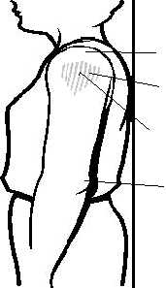
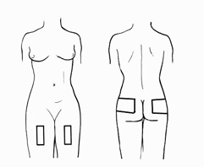

Deltoid muscle
(shaded area)

Reprinted with permission – The Minnesota Dept of Public Health
Reprinted with permission -
The University of Chicago

- Clean the area of skin with an alcohol swab.
- Remove needle cap if not already removed from drawing up the medication.
- Grasp muscle at injection site firmly between your thumb and fingers.
- Quickly insert needle at a 90-degree angle into muscle. (If your needle hits the bone, withdraw slightly and proceed.) See Figure 4 below for correct angle.
- Pull back gently on the plunger of the syringe; if no blood appears, inject the drug slowly.

Figure 4. 90-degree angle for intramuscular injection

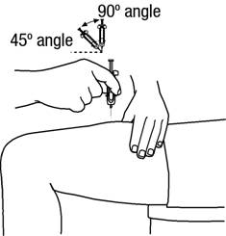

- If blood appears, withdraw the needle and apply gentle pressure to the site. Then change the needle and begin at another site.
- Withdraw the needle and apply gentle pressure with an alcohol swab, gauze, or tissue until any bleeding has stopped.
- Place a Band-Aid over injection site if needed.
- Be sure to rotate your injection sites when giving repeated injections.
- Discard uncapped needle and syringe into appropriate container.

